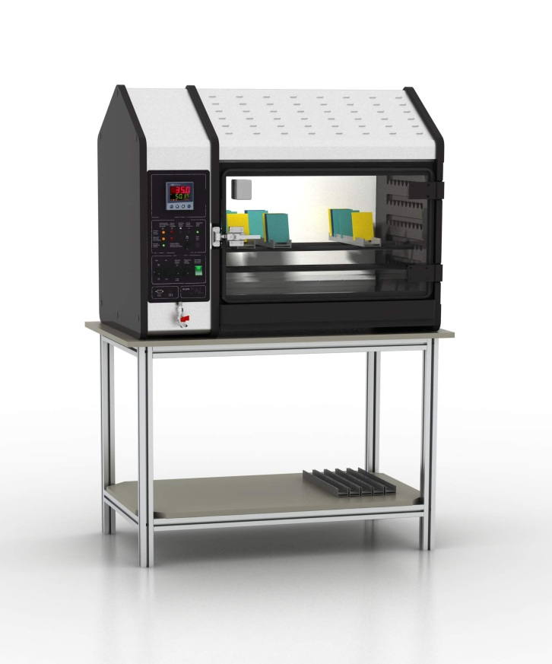

**Legend**

**CH – Constant Humidity**

**AT – Alternating Temperature**

**AHT- Alternating Humidity and Temperature**

**AIR – Forced air circulation**

**ADO – Automatic door opening**

**CWC – Controlled water condensation**

**SO2 – Automatic system for introducing SO2**

Figure 1 Patented Controlled Water Condensation (CWC) system

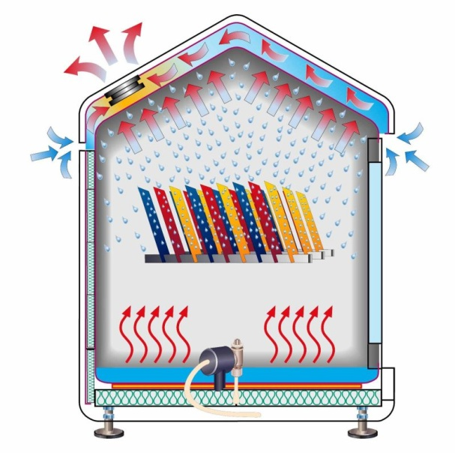

Figure 1 Patented Controlled Water Condensation (CWC) system

**Applicable for the following water condensation tests:**

**Constant Humidity (CH) test**

* **DIN EN ISO 6270-2:2005**
* **ASTM D2247**

**Cabinets with AIR or ADO option are applicable for the additional water condensation tests:**

* **alternating temperature (AT)**
* **alternating temperature and humidity (AHT)**

**The (SO2) version is suitable for conducting Kesternich tests acc. to:**

* **DIN EN ISO 6988**

**Product Description**

**These compact and easy to operate bench top cabinets are designed for conducting Constant Humidity (CH) and alternating temperature / humidity corrosion tests pursuant to the most common corrosion tests international DIN EN ISO 6270-2:2005 and ASTM D2247.**

**Customer Benefits**

* + Cost effective solution for basic water condensation and SO2 corrosion tests
  + Compact bench top design
  + The patented VLM technology allows the best possible reproducibility of the temperature conditions being created in the test chamber regardless the environmental conditions and geographical location – same type of VLM corrosion test chamber will produce same test results in any geographical region
  + The test chamber made of steel is more robust and less susceptible for damages compared to the competitive products made of glass reinforced plastic
  + Lower cost of ownership compared to the competitive products where the test chamber is made of glass reinforced plastic (shorter test periods, better energy efficiency, easier for service and maintenance, longer life cycle, more resistive to mechanical damages)
  + User friendly control system with preconfigured test parameters

**Order Information**

**Basic model: CON 300-FL**

**Article numbers versions:**

**V.702.061.000 (CH)**

**V.702.261.000 (AIR)**

**V.702.061.005 (ADO)**

**V.702.261.001 (AIR SO2)**

**V.702.161.000 (CH CWC)**

**V.702.361.000 (AIR CWC)**

**V.702.061.005 (ADO CWC)**

**Sales & Support:**

**+49 5205 97963 0**

Monday to Friday

8:00 am – 17:00 pm

VLM Labortechnik GmbH

Heideblümchenweg 50

33689 Bielefeld

[**info@vlmgmbh.de**](mailto:info@vlmgmbh.de)

[**www.vlmgmbh.de**](http://www.vlmgmbh.de)

Specification subject to changes

Pictures might differ from original

**D:\Users\Darko\Pictures\Marcom\phone_20icon_hfer.jpg**

|  |  |
| --- | --- |
| **Technical Specifications** | |
| **Capacity** | ca. 300 L |
| **Inner test chamber dimensions W/D/H1/H2** | ca. 800 x 605 x 533/720 mm |
| **Outer dimensions of the casing (overall) W/D/H** | ca. 1100 x 680 x 890 mm |
| **Required power supply** | 230V, 50/60Hz, 700W |
| **Materials used** | test chamber is made of stainless steel, bottom coated with ECTFE, side walls made of Polyethylene with milled openings for supporting rods |
| **Heating** | Flat Micanite heater under the bottom of the chamber for fast and uniform heat transfer |
| **Sensors** | - In basic type: 1x corrosion resistant and highly sensitive temperature sensor  - In CWC type: 2x corrosion resistant and highly sensitive temperature sensors above the floor and under the roof |
| **Temperature stability** | ±0,2 C° |
| **Aeration (type AIR)** | timer controlled built-in fan air flow ca. 16 m³/h |
| **Timer** | Two channel timer for automated switch over from heating to aeration mode |
| **Weight** | 110 kg |
| **Communication** | RS 232 interface |
| **Other specification** | |
| **Purity demineralized water / filling volume / fitting** | < 20µS/cm / ca. 3,5 L / ¾“ outer diameter  Option: Automatic water refill |
| **Tap water (connection type)** | Always via Ion-exchanging cartridge (¾“ outer diameter) |
| **Compressed Air** | 6-8 bar (connection nipple size 5) |
| **Waste water, drain** | Pipe fittings (spiral hose ID 18mm) |
| **Exhaust pipe outer diameter** | Pipe fitting (50 mm external diameter) |
| **Number of supporting rods / max load** | 5 stainless steel rods coated with plastic / 30 kg each |
| **Introduction of SO2** | Self-closing inlet valve at the right hand side wall |

**Relevant Test Standards:**

**Water condensation tests:**

DIN EN ISO 6270-2:2005

BS 3900 F2

BS 3900 F15

ASTM D2247

**Kesternich test:**

DIN EN ISO 6988

**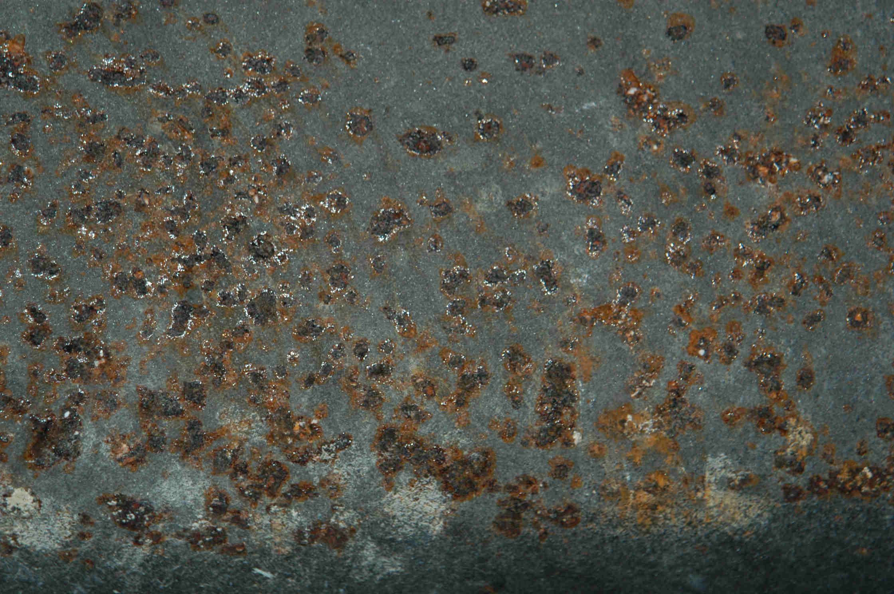**

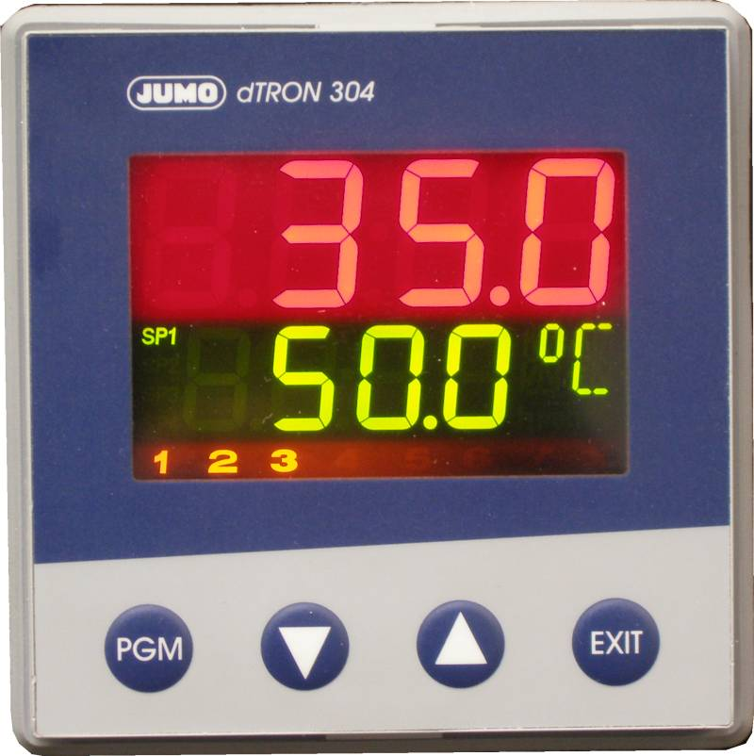

Figure 2 Jumo controller

**The following accessories are included:**

* **5 rods for supporting test specimen**
* **2 m exhaust hose Ø 50 mm**
* **2 m drain water hose Ø 18 mm**
* **1 female connector for compressed air hose (size no. 5)**

**Process Control**

* User friendly, microprocessor based controller (Figure 2)
* Programmable timer function
* Option: VisiCORR software for visualisation of test trends, only in combination with RS 232 (option)
* Restricted access for authorised operators (security code)

**Operating system Constant Humidity (CH) with Controlled Water Condensation - CWC (according to ISO 6270-2 H)**

* + CWC system (Figure 1) is the patented VLM technology which regulates the temperature gradient of exactly ∆T=1°C between the bottom and the roof of the test chamber – this is essential for an optimal condensation process in the test chamber at 100% RH regardless the environmental conditions outside the test chamber
  + Flat heaters under the bottom of the chamber for uniform and rapid heating of the water in the trough
  + Temperature stability in the chamber ± 0,2°C
  + Air fan with adjustable rotation speed for controllable drying of specimen in the Drying Phase; all MultiCORR® and ClimaCORR® types feature an extra air flow sensor which feeds the information about the air flow through the chamber back to the PLC controller which regulates the fan rotation speed according to common standard corrosion tests are already preconfigured

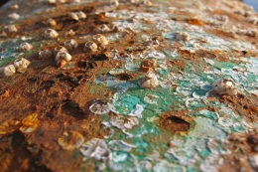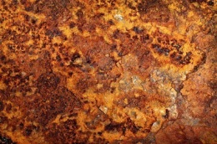

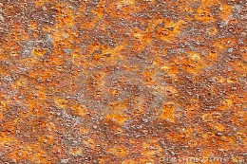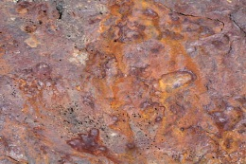

**Operating system AIR**

* A fan with controllable RPM is used for forced drying phase after the Constant Humidity phase

**Operating system ADO (Automatic Door Opening)**

* + System for automatic door opening after the Constant Humidity phase is finished – this allows drying of the specimens in environmental conditions

**Kesternich Test (SO2)**

**Operating system SO2**

The CON 300-FL with SO2 option allows carrying out Kesternich tests. There are two alternatives for dosing SO2 into the chamber:

* + Manual dosing system with the glass container and paraffin oil (Figure 3)
  + Electronic dosing system with electronic recording of the dosing quantities (Figure 4)

***Note:*** *The Fully automatic SO2 (Kesternich) test is only available with larger test cabinets (400 L, 1000L, 3500 L) which feature the PLC control system (Figure 5).*

The stainless steel bottle can be stored in a permanently ventilated cabinet installed in the bench underneath the test cabinet or in a special fire-resistant safety cabinet especially designed for storing SO2 gas bottles.

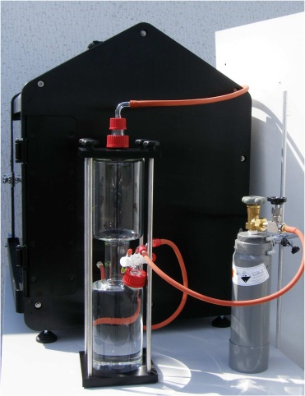

Figure 3 Manual dosing system for SO2

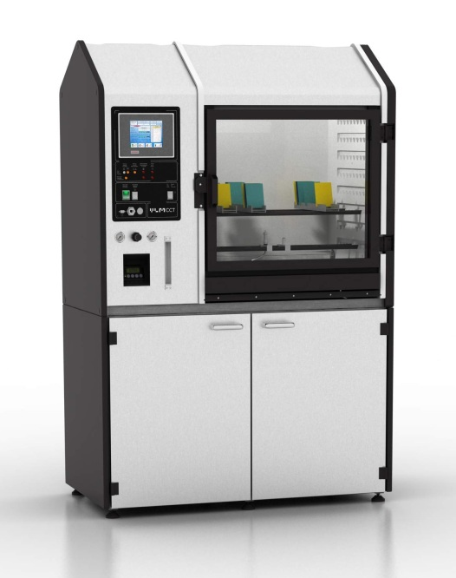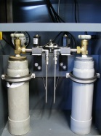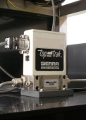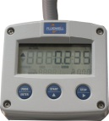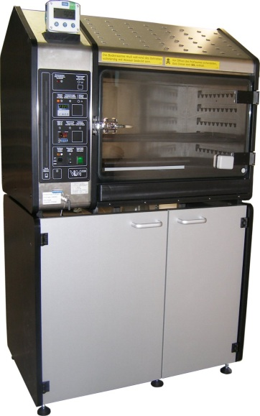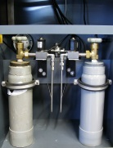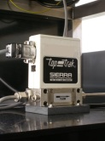

Figure 4 CON 300-FL with electronic dosing system for SO2

Figure 5 Fully automatic dosing system for SO2 in combination with the MultiCORR 400-FL test cabinet

**Notes:**